**Project 3:How to create private server to the internet using NAT Gateway(Jump server/Bastion host)**

* **Subnet created as a karthik-private-subnet-1**

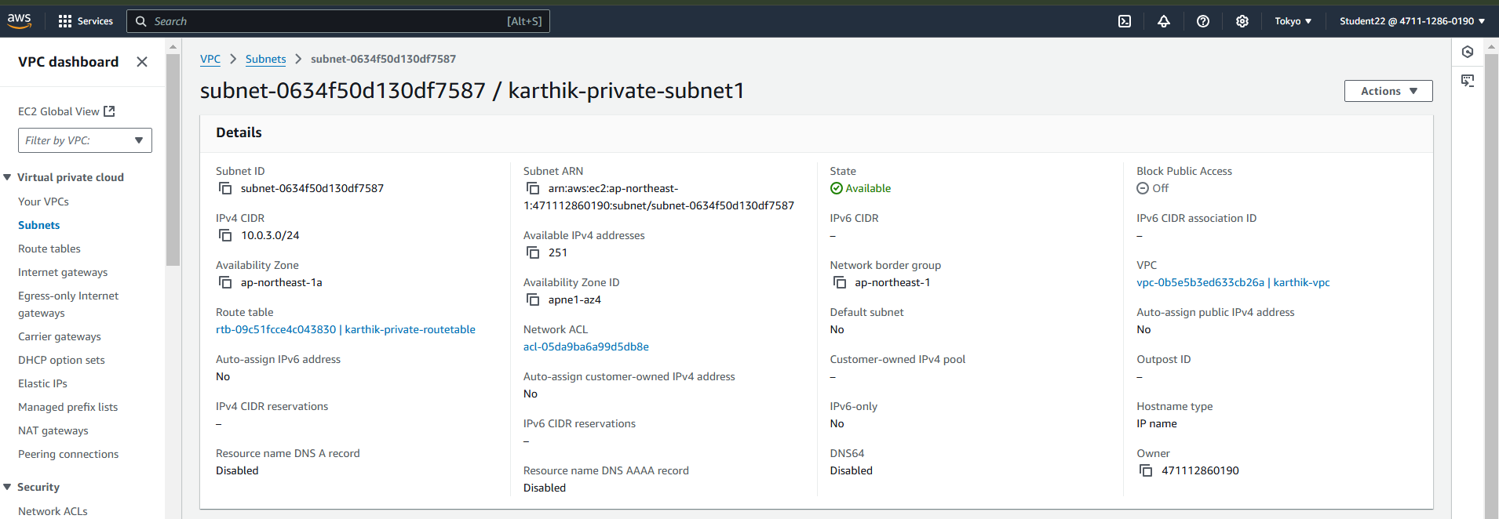

* **Subnet created as a karthik-private-subnet-2**

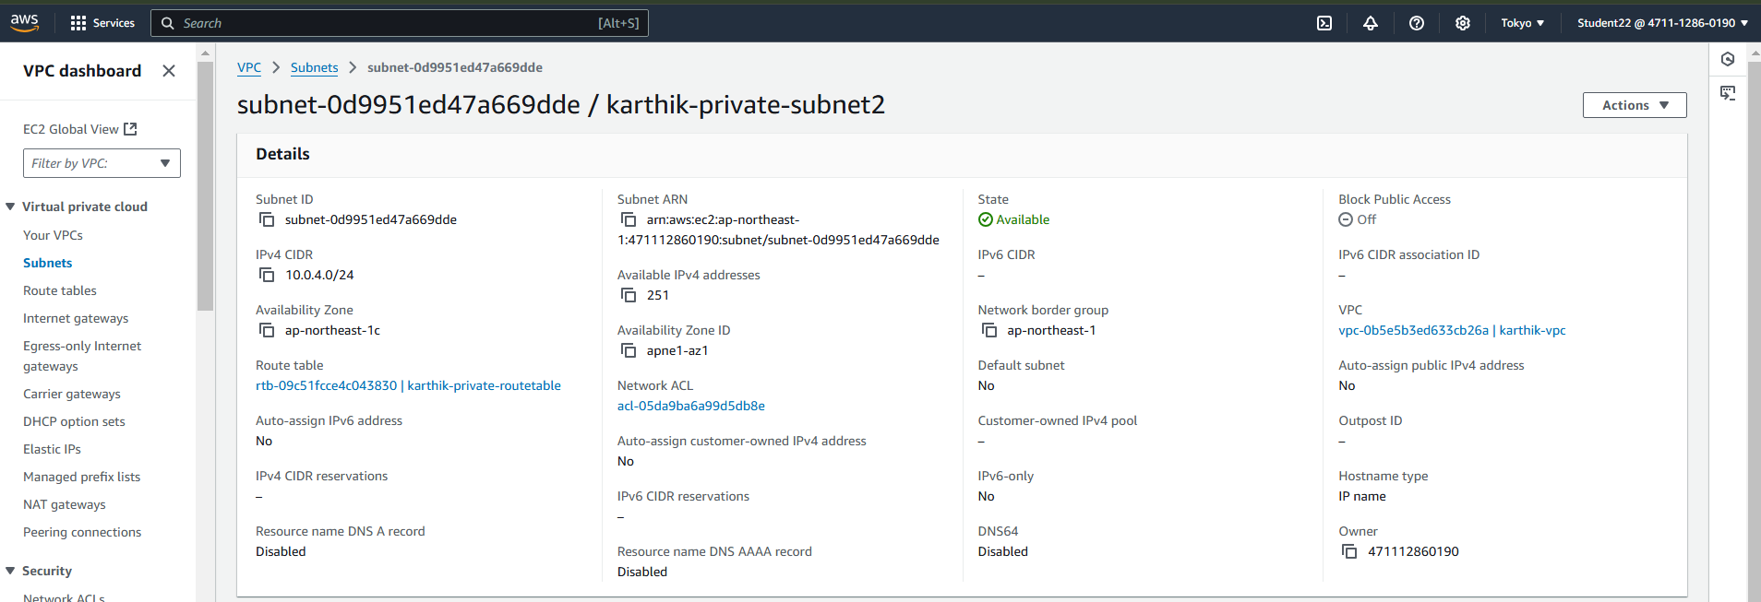

* **Routetable created as karthik-private-routetable**

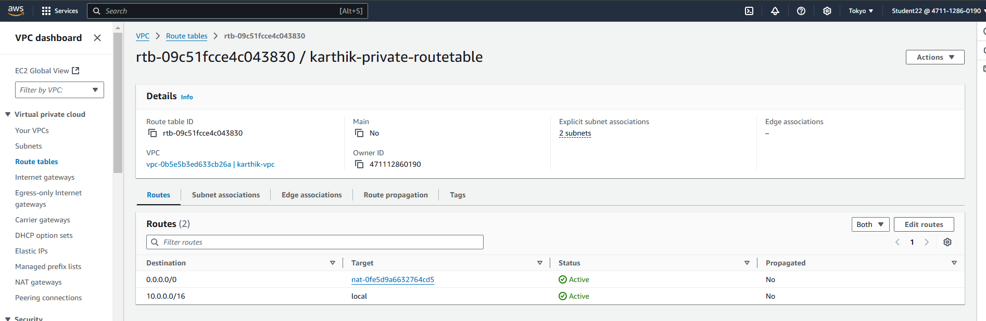

* **NAT gateway is created as karthik-NATgateway**

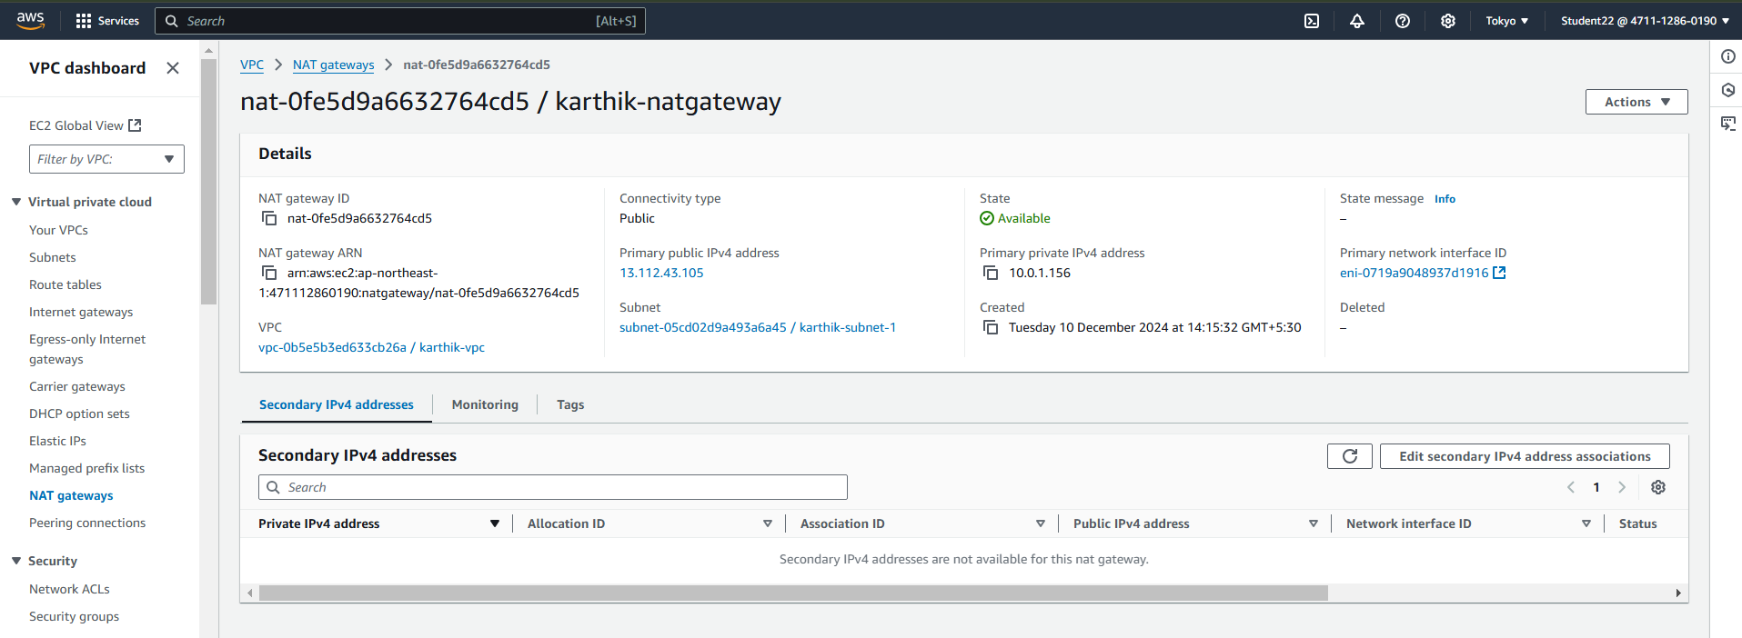

* **Edit Routes**

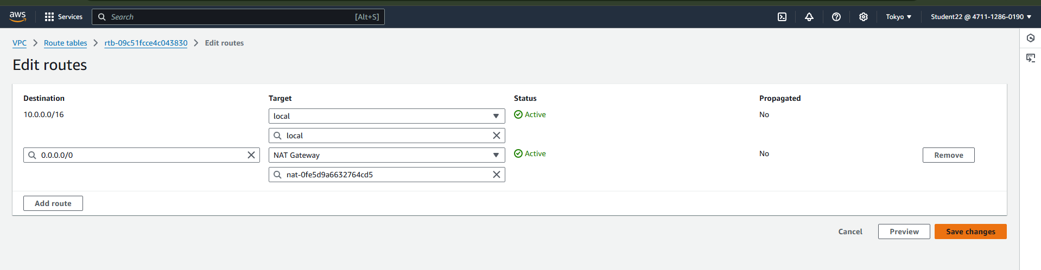

* **Creating private server in private subnet**

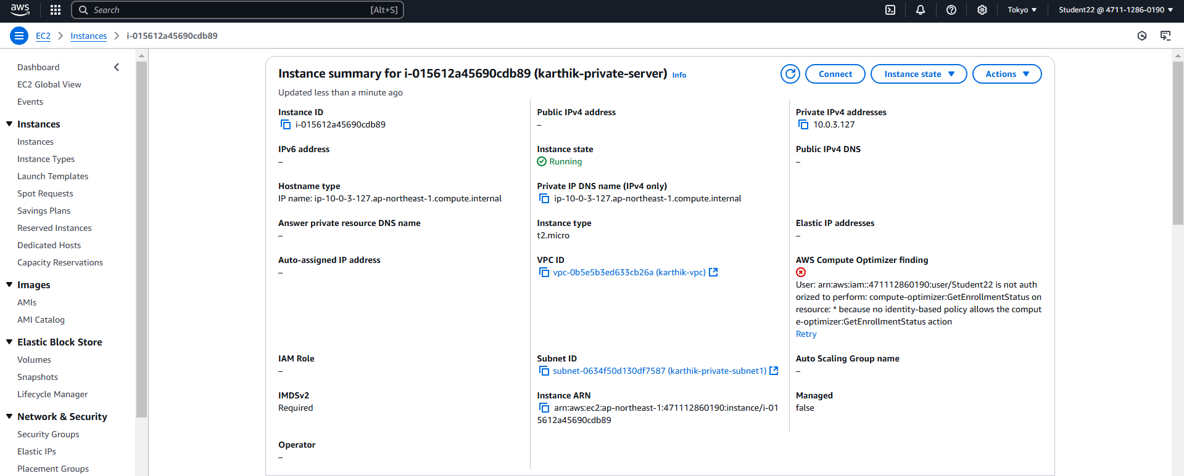

**Command prompt**

